Mr. Bryant
Heritage High School
Honors Mathematics II Syllabus
Office hours:
Location: room 604 or 634
After school: Tues, Thurs 2:30-3:30
Before school: Any day 6:30-7:20

and Class Outline

Introduction:
Hello, and welcome to Honors Math II. I am very excited to have you in my classroom this semester. I hope this class will be both an enjoyable and positive experience for you, however it will challenge you on many levels. I will challenge you to use techniques from previous courses as well as push you to understand and solve problems in a mathematical context. When you leave this course, you will have the knowledge and techniques to move on to more advanced mathematics and solve real world problems.

Course Objectives:
- see how mathematics is useful for solving the problems of real life,
- work together in groups to investigate, explore and have a deeper understanding of mathematical concepts,
- become proficient and successfully complete advanced Math II assessments,
- master the fundamentals of Math II so as to set a good foundation for college-track mathematics courses.
Materials:
I will provide you with materials for classroom purposes throughout the semester, however not everything will be provided. The following materials will not be provided to you and are recommended for this class as their use will be commonplace:

- Class Notebook (notes and homework)
- Binder if you want one (not required)
- Loose leaf notebook and graph paper
- Pencils with erasers
- TI-83 or TI-84

Course Timeline:
I will post a weekly outline on the board in the room as well as let students know when assessments are coming. I will also post much of this on my daily blog at my website www.mradambryant.weebly.com.

Grading Criteria:
Major Assessment 60% Minor Assessment 30% Homework 10% TOTAL 100%
Final Grade:
Q1: 40% Q2: 40% State Final Exam: 20%

Homework
Expect homework to be given EVERY night. I will check homework the next day and stamp it on your stamp sheet. You will only receive full credit if everything is done and you show work. Otherwise you will not receive credit until it is completed. If you miss work or have make up work to complete it is up to you to get the work and complete it. I will not remind your or let you know of missing work. If you turn in late work prior to the exam, it can earn a maximum of 60%, while after the exam but before the late work deadline will earn you a maximum of a 50%. There are HW help videos available through WCPSS on Canvas.

Re-test, Quiz Replacement:
If you are not satisfied with your test grade you may complete a re-test (maximum score of 90) to replace it if you have completed the unit homework, and come outside of class to complete your test corrections. When I pass back the tests, I will immediately announce and write the re-test date on the board. This is the only time you can take the re-test. If that date is not possible, come see me and we will discuss the conflict.
Lastly, if you receive a poor grade on a quiz, but receive a better grade on that unit’s test, the test grade will replace the poor quiz grade in the gradebook.

Assessments
Each unit will have two assessments. We will have a traditional exam and we will have a performance task where the student will complete an activity similar to the daily activities from the booklets. These will each be equally valued as major assessments when calculating the final grade. We will also rarely have review days before these exams. The homework each day will force students to continuously review so we will not require a separate day.

Expectations:
In my classroom, while I have a lot of expectations, they all branch out from a one main idea, respect.

I expect you to be respectful of me by:
- Listening and remaining quiet while I talk
- Having your homework out to check and working on the bell-ringer as soon as you sit down for class.
I expect you to be respectful of the school by:
- Not bringing food or drinks into the classroom
- Cleaning up your own messes (such as paper scraps)
I expect you to be respectful of others by:
- Respecting others’ boundaries, personal space, and opinions
- Sitting in your assigned seat
Lastly, I expect you to be respectful of yourself by:
- Not cheating, lying, or stealing
- Arranging a time to meet with me if you want or need extra help (My door is always open)

BYOD (Bring Your Own Device) at Heritage High School:
As of the 2016-17 School Year, HHS is officially a BYOD (Bring Your Own Device) School. As such, Students are required to sign the HHS/WCPSS BYOD Contract and Technology Usage Agreement. These forms only needs to be signed one time and will be kept on file. Other information concerning policies and procedures can be found at www.hhsbyod.weebly.com. However, the specific policy for mobile devices in every classroom is such:
- Students may use their devices in the classroom during instructional time…

  - Teachers will display a RED card/signal indicating that your device is powered off, put away, and is NOT in use.
  - Teachers will display a YELLOW card/signal indicating that your device is on silent and is face down on the desk. Student should ask before using.
  - Teachers will display a GREEN card/signal indicating that your device is in use as directed by the teacher.

- Around the School Building:
  - Red Zones: The device MUST be OFF and away at all times.
    - Restrooms
    - Locker rooms
    - Gym (Outside of Teacher directed instruction.)
  - Green Zones: The device, when in use, must be on SILENT or VIBRATE at all times.
    - Supervised Instructional Areas (i.e. Locker bays, Collaborative/Active Learning Spaces, the Media Center, and Outdoor classrooms)
    - Hallways
    - Cafeteria/Commons area
BYOD Inappropriate Use and Discipline:
Inappropriate use of devices in the classroom Teacher will give student two options:
- Choice 1 → Student can Personally place the device in a “Cell Jail” in a secured location in the classroom (i.e. File cabinet, Teacher Desk, anywhere that can be locked with teacher access.) and receive it back at the end of the class.
- Choice 2 → Student will be sent to the office.
- Note: On the second offense of inappropriate use, student no longer has a choice. It will default to the Admin option.

Internet Safety:
In accordance with Board Policy 2313/3013/4013 and the 21st Century Act (Public Law No: 110:385, Oct. 10, 2008) all students will be trained annually in Internet safety. School districts are required to educate students about:
- Appropriate online behavior, including interacting with other individuals on social networking websites and in chat rooms.
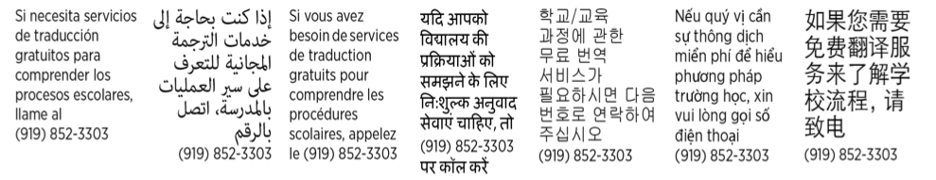
- Cyber bullying awareness and response.
------------------------------------------------------------------------------------------------------------------------------------------------------------

